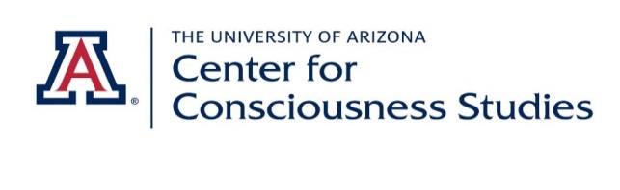

**For Release: March 31, 2016**

**Press Contact: Abi Behar Montefiore**

[**center@email.arizona.edu**](mailto:center@email.arizona.edu) **520-247-5785**

[www.consciousness.arizona.edu](http://www.consciousness.arizona.edu)

**Final 2016 Conference Program**

**The Science of Consciousness**

**April 25-30, 2016, Loews Ventana Canyon, Tucson, Arizona**

*“To have a glimpse of what consciousness is would be the scientific achievement before which all others would pale.”* - William James

After 23 years, the seminal conference 'Toward a Science of Consciousness' is now simply 'The Science of Consciousness'. But as consciousness cannot be observed, scientifically explained, nor commonly defined, *is* there now truly a 'Science of Consciousness'? Are we there yet?

We *do*have essential questions. Is the brain a computer? Does it process or generate conscious information as output?  When, where, and how did consciousness evolve? Can we have free will, or are we just 'along for the ride'? Will consciousness be reproduced through brain mapping, transhumanism and/or artificial intelligence? Or, does the brain 'tune into' and organize consciousness or its precursors existing naturally in the universe? What are the implications of either view on the nature of existence, and treatment of mental and cognitive disorders?

These and many other questions will be debated in a week-long gathering of 800 to 900 scientists, philosophers, artists, meditators and interested people from 50 countries at Loews Ventana Canyon, a luxurious eco-lodge in the mountains just north of Tucson, Arizona. The program will consist of Pre-Conference Workshops, Plenary talks, Concurrent talks, Posters, Exhibits, Social Events and Entertainment.

**Sponsored by   
Center for Consciousness Studies, The University of Arizona**

**Center for Consciousness Science, The University of Michigan**

**Important Links**

[Conference Trailer Video Link](https://www.youtube.com/watch?v=xJMYzeSwSGU&feature=youtu.be)​  
[Conference Website](http://www.consciousness.arizona.edu)  
[Registration Link](https://eagle.sbs.arizona.edu/sc/)

[Link to Abstracts](https://eagle.sbs.arizona.edu/sc/abs_report_bysession.ph%E2%80%8Bp)

**General Conference Sessions**

**PLENARY Program**   
[Link to Plenary Abstracts](https://eagle.sbs.arizona.edu/sc/abs_report_bysession.ph%E2%80%8Bp)

[Speaker Bios-click on photos](http://consciousness.arizona.edu/2016Plenary.htm)

 Tuesday, April 26, 2016 - 2:00 pm to 4:10 pm

**PL 1 -Five Roads to Consciousness (1)**

Stanislas Dehaene, NSERM-CEA, Paris

Anil K. Seth[,](http://consciousness.arizona.edu/2016PlenarySeth.htm) University of Sussex, Brighton

Stuart Hameroff, University of Arizona, CCS, Tucson

Wednesday, April 27, 2016 - 8:30 am to 10:40 am

**PL 2 - Brain Biology**

Rudolph Tanzi, Harvard Medical School, Boston

Selen Atasoy, Brain and Cognition, UPF, Barcelona

Anirban Bandyopadhyay, NIMS, Tsukuba

Wednesday, April 27, 2016 - 11:10 am to 12:30 pm

**PL 3 - Consciousness and Reality**

Deepak Chopra, Chopra Foundation, UCSD

David Chalmers, Australian National University, NYU

Wednesday, April 27, 2016 - 2:00pm to 4:10 pm

**PL 4 - Five Roads to Consciousness (2)**

Naotsugu Tsuchiya, Monash University, Melbourne

Richard Brown, CUNY, Laguardia College, New York

Jakob Hohwy, Monash University, Melbourne

Thursday, April 28, 2016 - 8:30 am to 10:40 am

**PL 5 - Conscious Intention and Free Will**

Aaron Schurger, École Polytechnique Fédérale, Lausanne

**Panel – Time, Free Will and the Brain**

Ruth Kastner, University of Maryland   
Daniel Sheehan, University of San Diego  
Ron Gruber, Stanford University   
Martin Nowakowski, Gdansk University  
Matti Vuorre, Columbia University   
Julia Mossbridge, IONS

Thursday, April 28, 2016 - 11:10 am to 12:30 pm

**PL 6 - AI/Machine Consciousness**

Hartmut Neven, Google

Christian Szegedy, Google

Friday, April 29, 2016 - 8:30 am to 10:40 am

**PL 7 - Quantum Approaches 1**

Henry Stapp, UC-Berkeley

Kelvin McQueen, University of Tel Aviv

Alyssa Ney, UC-Davis

Friday, April 29, 2016 - 11:10 am to 12:30 pm

**PL 8 - Evolution and Consciousness**

Terrence W. Deacon, UC-Berkeley

Katherine T. Peil, Northeastern U, Boston

Friday, April 29, 2016 - 2:00 pm to 4:10 pm

**PL 9 - 'Pribram Session' – Brain Dynamics**

Anthony Hudetz, University of Michigan, Ann Arbor

Walter J. Freeman, UC-Berkeley

György Buzsáki, NYU Neuroscience Inst, NYC

Saturday, April 30, 2016 - 8:30 am to 10:40 am

**PL 10 - Scale and Connectivity**

Alison Gopnik, UC-Berkeley

Robin Carhart Harris, Imperial College, London

Martin Monti, Psychology, UCLA

Saturday, April 30, 2016 - 11:10 am to 12:30 pm

**PL 11 - Quantum Approaches 2**

Dean Radin[,](http://consciousness.arizona.edu/2016PlenaryRadin.htm" \t "_blank) IONS, Petaluma

Stuart Kauffman, Institute for Systems Biology, Seattle

Saturday, April 30, 2016 - 2:00 pm to 4:10 pm

**PL 12  - NCC 3 -Anomalous Conscious Experience**

George Mashour, University of Michigan, Ann Arbor

Jimo Borjigin, University of Michigan, Ann Arbor

Peter Fenwick, Kings College, Southampton

|  |
| --- |
| **CONCURRENT SESSIONS** Tuesday April 26, Wednesday April 27, Friday April 29 -5:00 – 7:30 pm [Link to Concurrent Abstracts](https://eagle.sbs.arizona.edu/sc/abs_report_bysession.php?p=C)  **CONCURRENT SESSIONS C1-C8** |

Tuesday April 26, 2016   5:00 pm to 7:30 pm

C1   Knowledge Argument, Explanatory Gap and Conceivability

C2   Panpsychism, Idealism and Metaphysics 1

C3   Agency and Mental Causation

C4   Neural Correlate Of Consciousness (NCC) I

C5   Quantum Approaches

C6   Time and Consciousness

C7   Psi and Non-Locality

C8   Meditation and Technology

**Concurrent Sessions (C9-C16)**

Wednesday April 27, 2016  5:00 PM to 7:30 PM

C9    Phenomenal Consciousness

C10  Panpsychism, Idealism and Metaphysics 2

C11  Agency and Free Will

C12  The Extended Mind

C13  Neural Correlates of Consciousness 2

C14  Vibrations, Scale and Topology

C15  Cellular and Intra-Cellular Processes

C16  Meditation 2

**CONCURRENT SESSIONS (C17-C24)**

Friday April 29, 2016   5:00 PM to 7:30 PM

C17 Metacognition and Agency

C18  Panpsychism, Idealism and Metaphysics 3

C19  Unity and Self

C20  Ketamine and Anesthetics

C21  Sleep and Dreaming

C22  Machine Consciousness

C23  Quantum Biology

C24  Arts and Entertainment

**POSTER SESSIONS**

Poster Session 1

Wednesday April 27, 7:00 - 10:00 pm

Poster Session 2

Friday April 29, 7:00 pm to 10:00 pm  
[Link to Poster Abstracts](https://eagle.sbs.arizona.edu/sc/abs_report_bysession.php?p=P)

**ART/TECH/HEALTH EXHIBITS**

Session 1

Wednesday April 27- 7:00-10:00pm

Session 2

Friday April 29 - 7:00-10:00pm

[Art-Tech Design](http://consciousness.arizona.edu/2016ArtTechExhibitorSchedule.htm), [Health Technology Exhibits](http://consciousness.arizona.edu/2016ArtTechExhibitorSchedule.htm) [and Vendors](http://consciousness.arizona.edu/2016ArtTechExhibitorSchedule.htm)​

[Link to Art-Tech Abstracts](https://eagle.sbs.arizona.edu/sc/abs_report_bysession.php?p=A)

**SOCIAL EVENTS**

•    Club Consciousness / Hospitality Suite - Monday-Thursday 10:00 pm-midnight

•    Welcome Reception - Tuesday April 26, 7:00-10:00 pm

•    Dinner Under The Stars - Thursday April 28, 7:00-10:00 pm – optional

•    Poetry Slam/Zombie Blues/Talent Show - Friday April 29, 10:00 pm to midnight

•    'End of Consciousness' Party - Saturday, April 30, 8:00 pm to??

**CONSCIOUSNESS CENTRAL**

[Consciousness Central TV](http://www.ustream.tv/channel/consciousness-central-tv)

Daily roundup with speakers, guests, commentators and fun from The Science of Consciousness Conference, hosted by Nick Day and Cameron Keys

[**PRE-CONFERENCE WORKSHOPS**](http://consciousness.arizona.edu/2016WorkshopsFinal.htm)**April 25 and 26 (Optional)**

Workshop Descriptions and Speaker Bios – [here](http://consciousness.arizona.edu/2016WorkshopsFinal.htm)

Monday-Saturday daily sessions

**7:00 am – 8:00 am**

**Tenniscentric Approach to Consciousness**

Thursday, April 28 Tournament 3:00 pm

**Full Day East-West Forum**

**Sponsored by Dayalbagh Educational Institute, Agra**

**Monday April 25, 9:00am to 5:00pm**

The East-West Forum is now a familiar feature at the TSC series of conferences, starting with TSC 2012 at Tucson, TSC 2013 at DEI, Dayalbagh, India, TSC 2014 at Tucson again, and TSC 2015 at Helsinki, Finland.

The Fifth East-West Forum at TSC 2016 will be yet another landmark integration effort as part of the TSC-series. The above quote rather prophetically captures these momentous events, when not just two strong men from East and West stand face to face, but in fact, two galaxies of strong men and women from East and West meet at Tucson, Arizona (USA) and Dayalbagh, Agra (India) also through video-conferencing.

Pre-Conference Workshops-Link to Descriptions

**Monday Morning, April 25, 2016 9:00am-1:00pm**

Consciousness versus Attention

PSI Research and Consciousness

Consciousness, Memory and Music

Curriculum for Consciousness Studies

DEI East-West Forum   full day

Kant and the Conscious Mind-Salon

Altered State Healing in the Amazon

Quantum Biology - Nature of Life

**Monday Afternoon, April 25, 2016 2:00pm-6:00pm**

Consciousness in Animals

Consciousness and the Arts, I

Designing a Conscious Robot

DEI East-West Forum, II

Naturalizing the Conscious Mind?

Transformative Technology

Unity of Consciousness

**Monday Evening, April 25, 2016 7:30pm-10:00pm**

Super Genes – Can Consciousness Guide Evolution?

(Deepak Chopra, Rudy Tanzi)

**Tuesday Morning, April 26, 2016 9:00am-1:00pm**

Anesthesia Research and Consciousness

Complexity and Consciousness

Consciousness and the Arts II

Hot Topics in Cognitive Neuroscience

First Person-Third Person Perspectives

Philosophical Theories of Consciousness

Quantum AI and Machine Consciousness

Walter Freeman Festschrift

**Conference Opening**

**Tuesday April 26**

**1:45 Kiva**

**Co-Sponsors**

The Center for Consciousness Studies, The University of Arizona

The Center for Consciousness Science, The University of Michigan

**Additional Sponsors**

Dennis Balson

Mani Bhaumik

The Chopra Foundation

Crystal Globe, Shanghai

Alvin J. Clark

Ron Gruber

Irwin Klee, Quantum Gravity Research

Sofia University

Yet-A-Del Foundation

**Technology Exhibitors**

Dream Weaver

Neuroelectrics

HeartMathSoundsSelf

Starlab  
TruPhone

Quantum Gravity Research

**Additional Exhibitors**

JCS/Imprint Academic

CCS TUS Study

Erfan Keyhani (Halgheh)

**Additional Cooperating Organizations**

Center for Consciousness Studies, University of Arizona, TUS Study

College of Medicine, Department of Anesthesiology, University of Arizona

UA Departments of Psychology, Cognitive Science Program, Philosophy

Dayalbagh Educational Institute

Journal of Consciousness Studies – Imprint Academic

Society for Mind-Matter Research

Consciousness Central TV

Swiss Biennial on Science, Technics + Aesthetics

Human-Animal Interaction Research Initiative

Transformative Technology Lab

Planetary Science Institute

**Advertising Support**

Journal of Consciousness Studies

American Psychological Association

**Prizes**

Harmony Books /Penguin Random House

HEAD/Penn

OPRC KCUT

Whole Foods Tucson

**Music**

Dorian Electra and the Electrodes

Michael P and the Gully Washers

Timbre Wolf

**A/V**

Commotion Studios

**Program Committee**

Stuart Hameroff, Co-Chair, University of Arizona

George Mashour, Co-Chair, University of Michigan

Abi Behar-Montefiore, CCS, University of Arizona

Harald Atmanspacher, ETH Zurich

Brit Brogaard, University of Miami

Hakwan Lau, University of California at Los Angeles

Paavo Pylkkanen, Universities of Helsinki and Skovde

Jay Sanguinetti, University of Arizona

Marilyn Schlitz, Worldview Enterprises; IONS

Gino Yu, Hong Kong, Polytechnic Univ; SME Creativity Center

**Press**

Contact: [center@email.arizona.edu](mailto:center@email.arizona.edu)

Attn.: Abi Behar Montefiore

**The Center for Consciousness Studies – Since 1994**

The Science of Consciousness (TSC) is the largest and longest-running interdisciplinary conference emphasizing broad and rigorous approaches to conscious awareness, the nature of existence and our place in the universe. TSC brings together perspectives, orientations and methodologies from neuroscience, philosophy, medicine, quantum physics, cosmology, biology, psychology, anthropology, artificial intelligence, technology, contemplative and experiential traditions, the arts, culture, humanities and others. Cutting edge, controversial issues are emphasized.

TSC 2016 marks the 23rd annual TSC Conference and we are thrilled to return to Loews Ventana Canyon. The TSC conferences are held in Tucson biennially since 1994, and co-sponsored TSC conferences occur elsewhere around the world in odd-numbered years, most recently in Helsinki, Finland in June 2015, organized by Paavo Pylkkanen, The University of Helsinki, and Skovde University, Sweden. Next year, the 24th conference, TSC 2017, will be held in Shanghai, China, co-sponsored by Crystal Globe, Shanghai, China. TSC 2016 and future TSC conferences are co-sponsored and organized by the Center for Consciousness Studies at the University of Arizona, Tucson, and the Center for Consciousness Science, The University of Michigan, Ann Arbor.

**History of TSC**

The first TSC conference was held in 1994 in DuVal Auditorium at the University of Arizona Medical Center, and subsequently elsewhere in Tucson in even-numbered years. These have alternated with co-sponsored international TSC conferences in various locations around the world in odd-numbered years. The Center for Consciousness Studies (CCS) at the University of Arizona was established in 1998 by the Arizona Board of Regents. TSC and CCS are due to the work over the years of Al Kaszniak, David Chalmers, Jim Laukes, Jay Sanguinetti, Stuart Hameroff and the late Alwyn Scott, a co-founder of CCS. Since 2007, CCS and TSC have been successfully managed by Abi Behar-Montefiore, subsisting entirely on TSC conference registration fees and sponsorships. CCS is hosted in the Department of Anesthesiology in the University of Arizona College of Medicine, and Banner-University Medical Center.

Thank you to our international colleagues and friends who helped make TSC alternate year conferences possible:

1995 Ischia, Italy; Chloe Taddei-Ferretti

1997 Elsinore, Denmark; LO Skolen, Alwyn Scott

1999 Tokyo, Japan; UN University, Mari Jibu, Kunio Yasue

2001 Skovde, Sweden; University of Skovde, Paavo Pylkkanen

2003 Prague, Czech Republic; Ivan Havel

2005 Copenhagen, Denmark; Morten Overgard

2007 Budapest, Hungary; George Kampis

2009 Hong Kong, China; Hong Kong Polytechnic, Gino Yu

2011 Stockholm, Sweden; Christer Perfjell

2013 Agra, India; Rev. Prof. PS. Satsangi; Vishal Sahni

2015 Helsinki, Finland; University of Finland, Paavo Pylkkanen

2017 Shanghai, China - tba

Conference Website

Center for Consciousness Studies

University of Arizona

[www.consciousness.arizona.edu](http://www.consciousness.arizona.edu)

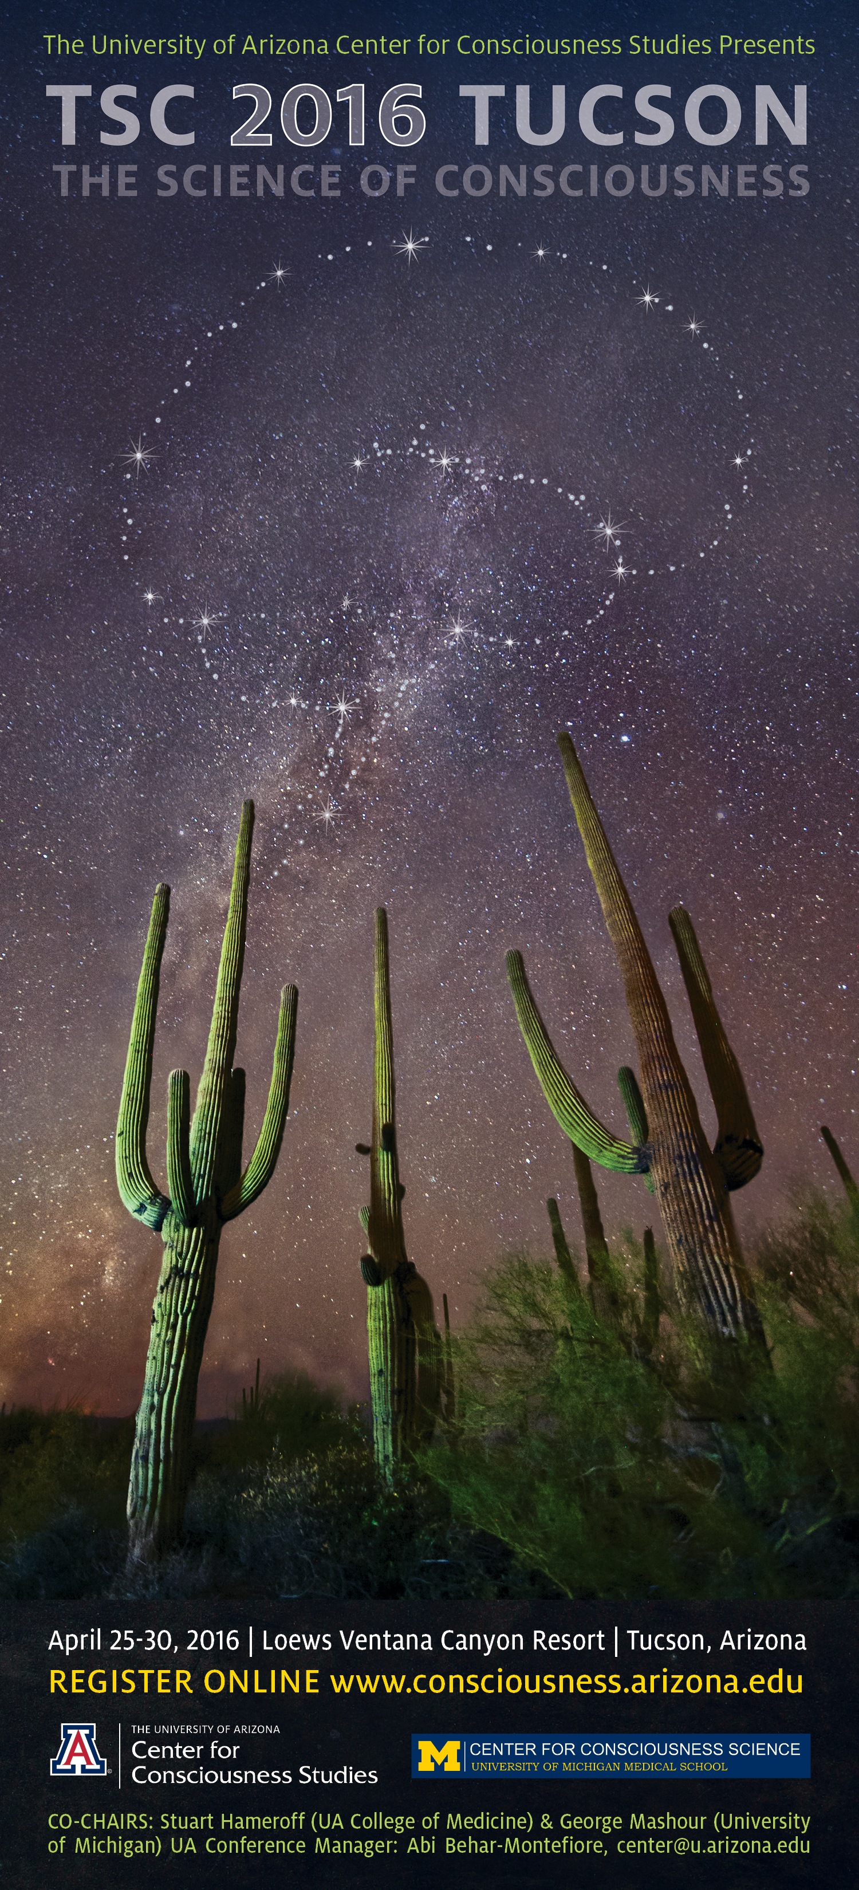

Artwork: Roma Krebs, BioCommunications