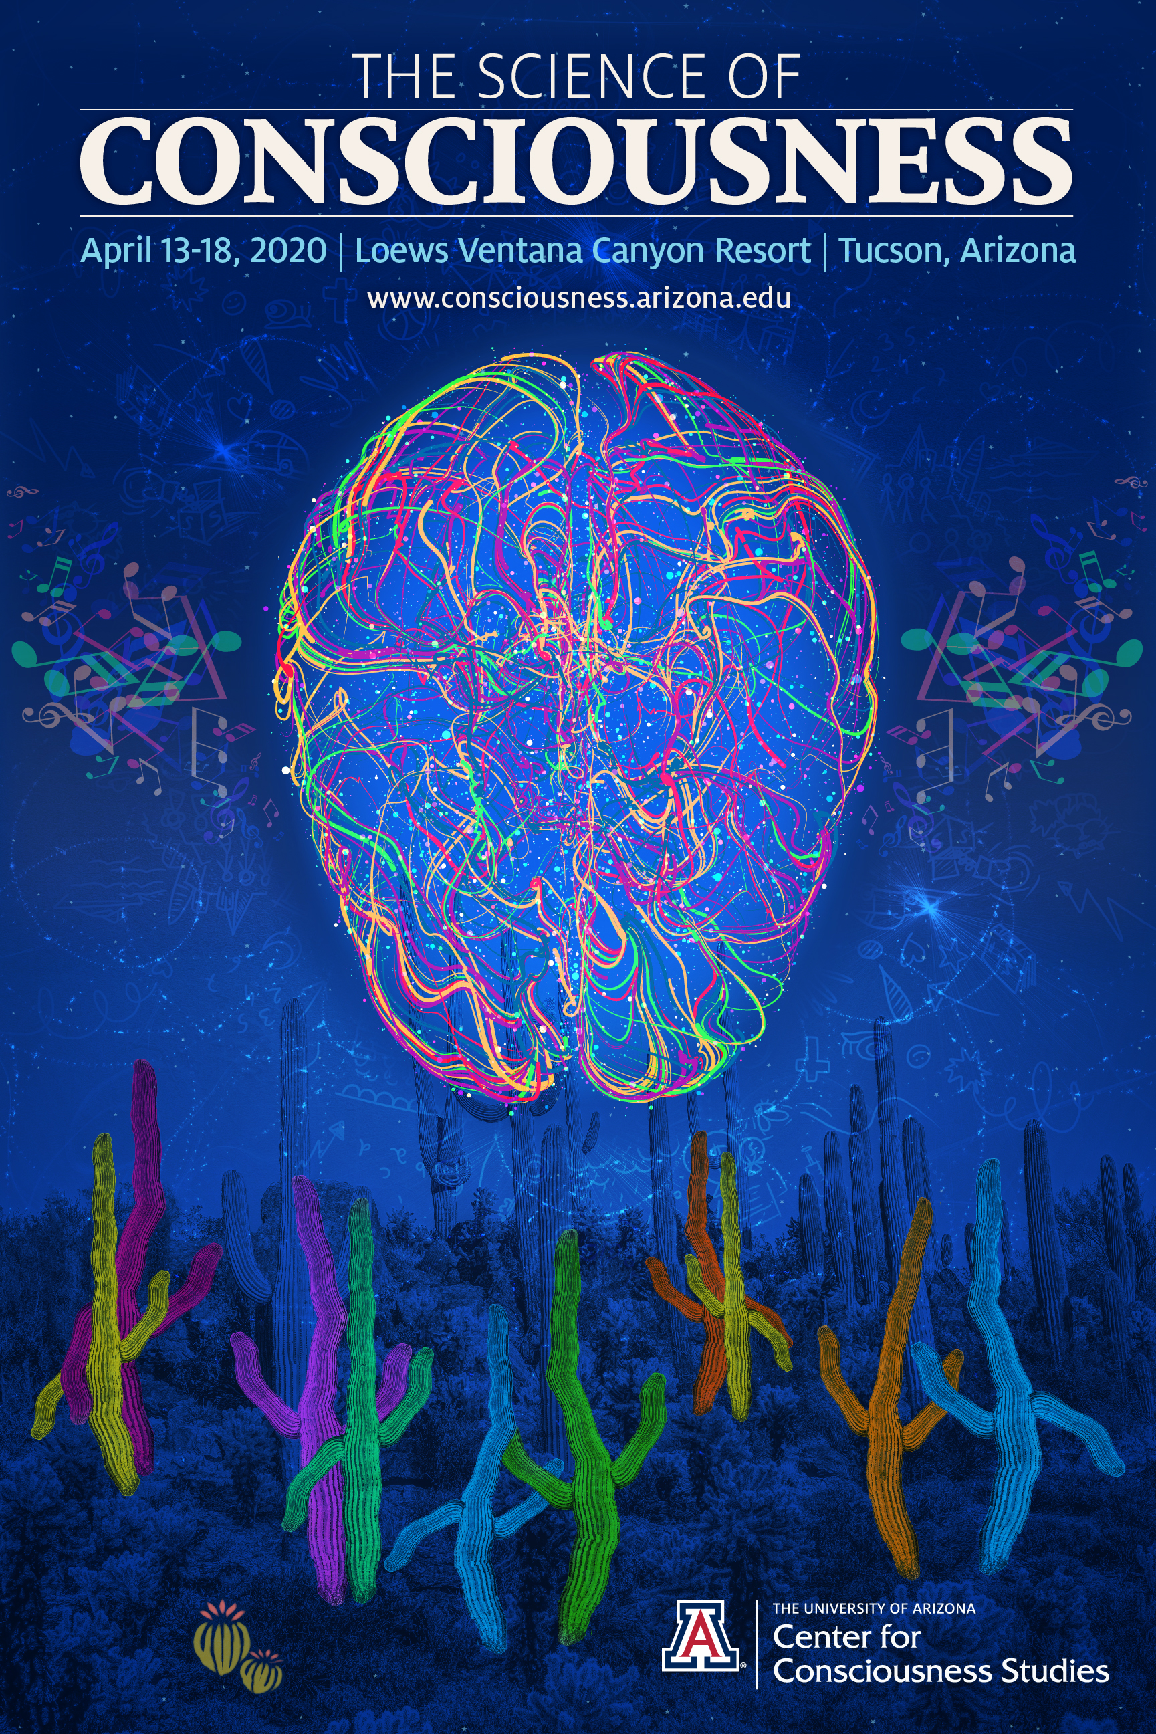
The Science of Consciousness April 13-18, 2020
Loews Ventana Canyon Resort, Tucson, Arizona
First Announcement and Call for Abstracts
Conference website: www.consciousness.arizona.edu
The Science of Consciousness (‘TSC’) is an interdisciplinary conference emphasizing rigorous approaches to all aspects of the study of consciousness and its place in the universe. Topical areas include neuroscience, philosophy, psychology, cognitive science, biology, quantum physics, meditation, altered states, artificial intelligence/machine consciousness, the nature of reality, culture and experiential phenomenology.
Held annually since 1994, the TSC conference is hosted by the Center for Consciousness Studies at the University of Arizona, and alternates yearly between Tucson, Arizona and various international locations, most recently Interlaken, Switzerland in June of 2019, organized by Harald Atmanspacher, ETH Zurich. The next TSC conference will be held April 13-18, 2020 at the Loews Ventana Canyon Resort, a beautiful eco-lodge in the hills above Tucson, Arizona. Tucson TSC conferences generally attract ~ 700 attendees or more, and consist of Keynote, Plenary and Concurrent talks, Posters, Exhibits, Workshops and Social Events.
Preliminary Plenary Program
(Dates, times and additional sessions and speakers to be announced)

Keynote
Edvard Moser (Nobel Laureate), NTNU, Trondheim, Norway
Space and time in the brain

Keynote
Michael Pollan, UC Berkeley, Harvard, author
Consciousness and psychedelics

Consciousness and Time
Carlo Rovelli, Aix-Marseilles U
Dean Buonomano, UCLA
Sylvie Droit-Volet, U Clermont’
Consciousness, Reality and Illusion
Don Hoffman, UC Irvine
Keith Frankish, U Sheffield

Free Will and Consciousness
Uri Maoz, Chapman U
Walter Sinnott-Armstrong, Duke U
Amir Raz, Chapman U
Eve Isham, U Arizona

Consciousness and Non-Invasive Brain Modulation
Alexander Bystritsky, UCLA
Shinzen Young, U Arizona

Origin of EEG Rhythms
Paul L Nunez, Tulane
Alysson Muotri, UCSD
Horacio Cantiello, UNSE Argentina

Debate: Are Plants Conscious?
Monica Gagliano, U Sydney
Jon Mallatt, Washington State U

Music, Resonance and Consciousness
Lawrence Zbikowski, U Chicago
Selen Atasoy, Oxford
Jonathan Schooler/Tam Hunt, UCSB

Is the Universe Conscious? Cosmopsychism and Eastern Approaches
Miri Albahari, U Western Australia
Deepak Chopra, Chopra Global
Philip Goff, Central European University

Consciousness and Psychedelics
Dennis McKenna, Heffter Research Institute
Christopher Timmerman-Slater, UCL
Mark Rasenick, UI Chicago

Quantum AI and Consciousness
Hartmut Neven, Google Quantum AI
Peter Read, Cortex/Vitruvian Partners

Additional Plenary Sessions and Pre-Plenary Workshops
(April 13 morning and afternoon, and April 14 morning)
Conscious Vision and Predictive Coding
Time and Consciousness
Language and Consciousness
Quantum Psychopathology
Photons and Entanglement in the Brain
Mathematical Approaches to Consciousness
Consciousness and Education
Evolution and Consciousness
Psychedelics and Consciousness
Quantum Biology
Brain Stimulation
Meditation and Consciousness
Pain, Consciousness and Addiction
Plants and Consciousness

Online Abstract Submission system – now open
https://eagle.sbs.arizona.edu/sc/
Registration Payment system – opens November 1
https://eagle.sbs.arizona.edu/sc/

Taxonomy
Major Categories:
1: Philosophy
2: Neuroscience
3: Cog-Sci/Psychology
4: Physics/Biology
5: Experiential
6: Humanities

Subthemes: See conference taxonomy

Abstract Guidelines
Submission Length: 500 words

Identify your preference for presentation format in the comments section.
- Oral Presentation Only
- Poster Presentation Only
- No Preference
Plenary – Oral Presentation
- The most highly-ranked peer-reviewed submissions will be accepted and scheduled as oral presentations during Plenary Sessions.

Concurrent – Oral Presentation (Tuesday April 14, Wednesday April 15 and Friday April 17, 5pm to 7pm)

- These are 20-minute talks including 5 minutes discussion in concurrent theme-based sessions.
- There are 5 presenters per concurrent session

Poster Sessions – Wednesday April 15 and Friday April 17, 7 pm to 10 pm in the Grand Ballroom
(see website for specifications) www.consciousness.arizona.edu

Workshop Proposals – please email: center@email.arizona.edu Workshops are 4 hour sessions Monday morning April 13, 9 am to 1 pm; Monday afternoon 2 pm to 6 pm; Tuesday morning 9 am to 1 pm. Deadline for proposals is October 15th.

Social Events (included in Registration):
- Tuesday Welcome Reception – 7-9 pm
- Wednesday and Friday Poster Receptions 7-9 pm
- Friday evening Poetry Slam – 9pm-12midnight
- Saturday Closing party dinner – 7-11pm
- Daily Meditation with Deepak Chopra – times tba

Conference Dinner – optional
- Thursday evening 7-10 pm

Deadlines:
October 15 Workshop Proposals Deadline
October 30 Workshop Notifications
December 1 General Conference Abstracts Deadline
December 15 General Conference Abstract Notifications
December 20 Early Registration Deadline
February 15 Final Program and Abstract Revisions

Registration Fees:
Standard $550
Students $450
Thurs. Dinner $80
Thursday April 16 afternoon - free time
Loews Hotel offers free shuttles to Sabino Canyon approx. 2 miles from the resort. The Hotel also offers free shuttles to nearby shopping including banks, supermarket, pharmacy, etc. Car Services are available to outdoor plazas including La Encantada, Philipps Plaza, (within 10-15-minute drive) and to the University (approximately 25 minute drive)

Additional activities to be announced

Abstract and Program Books
provided at the conference for paid attending registrants

Journal Advertising
Full page only

Sponsorships

Exhibitor Space
For Information Contact: center@email.arizona.edu

2020 Program Committee

Chair
Stuart Hameroff
Director, Center for Consciousness Studies
University of Arizona, Tucson, AZ

Co-Chairs
Thomas G. Bever
Regent's Professor
Co-Director, Center for Consciousness Studies
University of Arizona, Tucson, AZ

Jay Sanguinetti
Associate Director, Center for Consciousness Studies
University of Arizona, Tucson, AZ

Abi Behar Montefiore
Assistant Director, CCS
University of Arizona

TSC 2020 Program Advisors

Selen Atasoy, Imperial College
Harald Atmanspacher, ETH Zurich
Betsy Bigbee, CCS
Olga Bever, University of Arizona
Alvin J Clark, CCS
Eve Isham, University of Arizona
Lynn Nadel, University of Arizona
Paavo Pylkkanen, University of Helsinki

General Information, Letters of Invitation for Registrants and Press Contact:
Abi Behar Montefiore, center@u.arizona.edu,
tel: 520-621-9317 http://www.consciousness.arizona.edu

# # #
9-25-19; rev 9-27-19

