Conference Announcement and Call for Abstracts (9-3-15)
THE SCIENCE OF CONSCIOUSNESS
(Formerly, 'Toward a Science of Consciousness')
April 25-30, 2016
Loews Ventana Canyon Resort
Tucson, Arizona

To view trailer, click on image

https://www.youtube.com/watch?v=xJMYzeSwSGU&feature=youtu.be

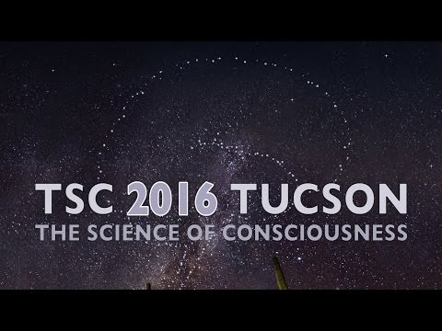

Pondered since ancient times, the nature of consciousness remains deeply mysterious and profoundly important, its implications ranging across science, philosophy, art, spirituality, medicine, contentment, the meaning of existence and perhaps even human survival. We know what it is like to be conscious - to have awareness, a conscious 'mind', thoughts and feelings, but who, or what, are 'we' who know such things? How does the brain, a material object, produce the subjective nature of phenomenal experience - our mental 'inner life'?

The modern science of consciousness began in the late 1980s with books on the topic by Nobel Laureates Francis Crick and Gerald Edelman, and British physicist Sir Roger Penrose. In 1994 the first 'Tucson conference', 'Toward a Science of Consciousness' was held at the University of Arizona in Tucson. It was an interdisciplinary gathering of neuroscientists, philosophers, psychologists, physicists, physicians, mathematicians, biologists, spiritualists and interested lay people from around the world. The conferences have continued, alternating between Tucson and elsewhere internationally, with TSC 2016 the 22nd annual meeting.

Where do we stand now? Do we truly have a 'Science of Consciousness'? Clearly, we don't yet have the answers, but we are beginning to ask proper questions. Here are some of them.

How do conscious brain activities differ from non-conscious brain activities? Is consciousness continuous, or a sequence of discrete events? How does consciousness relate to the flow of time? Does consciousness emerge from complex computation among brain neurons, e.g. characterized by integrated information, global workspace, predictive coding, 'higher order thought', scale-invariance, pre-frontal feedback, moving zones, coherent volleys and/or synchronous oscillations? How do anesthetics selectively erase consciousness? How do psychoactive drugs and meditation alter it? Can consciousness be mapped, downloaded and preserved in artificial media? Can neural correlates of consciousness also be causes of consciousness? Did consciousness evolve de novo as an adaptation of biological complexity?

Or is something else at play? Philosophical dualists, panpsychists, spiritualists and proponents of quantum brain biology suggest that mental qualities or conscious precursors are somehow intrinsic features of the universe, that consciousness has, in some sense, been here all along. Can consciousness be identified with 'collapse of the quantum wavefunction'? Is it necessary for a physical 'theory of everything'? Can consciousness exist independently of biology? Did mental qualities precede life on earth, prompting its origin and evolution?

The Science of Consciousness (TSC) 2016 Conference is jointly sponsored by the Center for Consciousness Studies at the University of Arizona, and the Center for Consciousness Science at the University of Michigan, and will be held at the Loews Ventana Canyon Resort in Tucson, Arizona April 25-30, 2016. Some 700 people are expected for a week-long program of plenary and concurrent talk sessions, posters, art/tech demos, pre-conference workshops, recreation and social events including a welcome reception, conference barbecue and square dance, the traditional Poetry Slam/Zombie Blues/talent show, and closing 'End-of-Consciousness' party.

Themes and topics will include:

- Three Roads to Consciousness: 'GW', 'PC' and 'HOT'
- Moving From Correlates to Causes of Consciousness
- Machine Consciousness and Artificial Intelligence
- Origin and Evolution of Life and Consciousness
- Quantum Brain Biology
- Transcranial Brain Stimulation
- The 'Pribram Session' - Levels, Scale and Content of Consciousness
- Mechanisms of Anesthesia and Psychoactive Drugs
- Virtual Reality
- Consciousness and Collapse of the Wavefunction
- End-of-life Brain Activity

Plenary speakers will include:

- Gyorgy Buzsaki, NYU Neuroscience Institute, New York
- Stanislas Dehaene, INSERM-CEA, Paris
- Stuart Kauffman, The Institute for Systems Biology, Seattle
- Anil K. Seth, University of Sussex, Brighton
- Aaron Schurger, Ecole Polytechnique Federale, Lausanne
- Wolf Singer, Max Planck Institute for Brain Research, Frankfurt
- Biyu Jade He, NIH/NINDS, Bethesda
- Anthony Hudetz, University of Michigan Medical School, Ann Arbor
- Jimo Borjigin, University of Michigan, Ann Arbor
- Henry Stapp, University of California, Berkeley
- David Chalmers, Australian National University; New York University
- Rudolph Tanzi, Harvard Medical School, MGH, Boston
- Deepak Chopra, Chopra Center, Carlsbad; College of Medicine, UC San Diego
- Alison Gopnik, University of California, Berkeley
- Patricia Churchland, University of California, San Diego
- Anirban Bandyopadhyay, Natl. Inst. for Materials Science, Tsukuba
- Alyssa Ney, University of California, Davis
- Katherine T. Peil, Northeastern University, Boston
- Jakob Hohwy, Monash University, Melbourne

Conference Website
www.consciousness.arizona.edu

Sponsors
Center for Consciousness Studies, The University of Arizona
Center for Consciousness Science, The University of Michigan

Co-Chairs
Stuart Hameroff
University of Arizona, Banner University Medical Center,
Center for Consciousness Studies, Tucson
George Mashour
The University of Michigan Medical School,
Center for Consciousness Science, Ann Arbor

Program Advisory Committee
Hakwan Lau, UCLA
Harald Atmanspacher, ETH Zurich
Paavo Pylkkanen, Universities of Helsinki and Skovde
Brit Brogaard, University of Miami
Program Advisor
David Chalmers, New York University
Cooperating Organizations
Society for Mind-Matter Research
DEI, Dayalbagh Educational Institute, Agra
Swiss Biennial on Science, Technics, Aesthetics

Call for Conference Abstracts
Submitted abstracts will be considered for:

- Plenary (sessions held Tues, Wed, Thur, Fri, Sat)
- Concurrents (sessions held afternoons: Tues, Wed, Fri)
- Poster Sessions / Art Tech (held Wed and Fri evenings)

The Online Abstract System will open September 15, 2015
Please see the Conference Website: www.consciousness.arizona.edu
for the following information:

- Abstract Submission Guidelines
- Workshop Proposal Guidelines
- Art-tech-film Call for Exhibit Proposals

General Conference Registration - Online Registration System Opens: September 15, 2015

Early Registration
September 15-December 15

- Adults: $550
- Students $400

Registration includes
Access to Conference Plenary, Concurrent, Poster, Art Sessions, Welcome Reception, Poster Receptions, Poetry Slam/Zombie Blues, End-of-Consciousness Party
(additional fees for guests, trips and conference dinner)

Late Registration

- December 16 - conference
- Adults $600
- Students $450

Forms of Payment

- Online Registration System
- Wire Transfer
- Checks-Money Orders

Questions:
center@u.arizona.edu

Additional Information will be posted on the Conference Website:
Workshops/Forums, Side Trips, Conference Dinner, Evening Shuttles to Downtown
Car Services to Airports, Additional housing options, Applications for Conference Sponsors

Conference Manager
Abi Behar Montefiore
Center for Consciousness Studies
Department of Anesthesiology
University of Arizona Tucson
cell/text 520-247-5785
email: center@u.arizona.edu
http://www.consciousness.arizona.edu

Hotel-Venue
Loews Ventana Canyon Resort Tucson
$109 Conference Rate
Loews Ventana TSC 2016 Conference - Hotel Booking Link

TSC 2016 VENUE
CONFERENCE HOTEL BOOKING LINK

Loews Ventana Canyon Resort
BOOK NOW Hotel Booking Link for
The Science of Consciousness
Special rate
for Conference Attendees Only
$109 plus tax
based on availability and paid conference registration by 2/25

Main Conference Schedule

Plenary sessions (PL1-PL12)

- Tuesday April 26, (1) 2:00 pm to 4:10 pm
- Wednesday April 27, (2) 8:30 am to 10:40 am; (3) 11:10 am to 12:30 pm; (4) 2:00 pm to 4:10 pm
- Thursday April 28, (5) 8:30 am to 10:40 am; (6) 11:10 am to 12:30 pm (Afternoon free)
- Friday April 29, (7) 8:30 am to 10:40 am; (8) 11:10 am to 12:30 pm; (9) 2:00 pm to 4:10 pm
- Saturday April 30, (10) 8:30 am to 10:40 am; (11) 11:10 am to 12:30 pm; (12) 2:00 pm to 4:10 pm

Concurrent Talk Sessions (C1-C21)

- Tuesday April 26 (1-7), 5:00 pm to 7:05 pm
- Wednesday April 27 (8-14), 5:00 pm to 7:05 pm
- Friday April 29 (14-21), 5:00 pm to 7:05 pm

Poster Sessions (P1-P2)

- Wednesday April 27 (1) 7:00-10:00 pm
- Friday April 29 (2) 7:00-10:00 pm

Art/Tech/Film Demos

- Wednesday April 27 (1) 7:30-9:00 pm
- Friday April 29 (2) 7:30-9:00 pm

Social Events

- Hospitality Suite Nightly
- Welcome Reception-Tuesday April 26, 6:30-9:30 pm
- Optional Trips-Thursday April 28, 1:00-5:30 pm
- Dinner-BBQ-Square Dance-Thursday April 28, 6:30-9:30 pm
- Poetry Slam-Zombie Blues-Talent Show Friday April 29, 10:00 pm to midnight
- "End of Consciousness" Party Saturday, April 30, 8:00 pm to ??

Abstract Submission Schedule and Important Registration Deadlines
- September 15, 2015 Registration and Abstract Submission System Opens
- September 30, 2015 Deadline for Workshop Proposals
- October 15-30, 2015 Workshop Notifications
- December 15, 2015 Deadline for General Conference Abstracts
- January 5, 2016 Abstract Notifications begin
- January 15 Early Conference Registration Deadline
- March 25 Hotel Reservation Deadline
- April 25-26 Pre-Conference Workshops
- April 26-30 Plenary, Concurrent, Poster, Art-Tech-Film Sessions

Questions:
Please Contact
The Center for Consciousness Studies
University of Arizona
center@u.arizona.edu
www.consciousness.arizona.edu
See you in Tucson.

# # #

The Science of Consciousness (TSC) is an interdisciplinary conference aimed at rigorous and leading edge approaches to all aspects of the study of conscious experience. These include neuroscience, psychology, philosophy, cognitive science, artificial intelligence, molecular biology, medicine, quantum physics, and cosmology, as well as art, technology, and experiential and contemplative approaches.
The conference is the largest and longest-running interdisciplinary gathering probing fundamental questions related to conscious experience. As in previous conferences, program sessions will include plenary and keynote talks, concurrent talks, posters, art-science-film demos and exhibits, pre-conference workshops, side trips, and social events in the Tucson tradition.

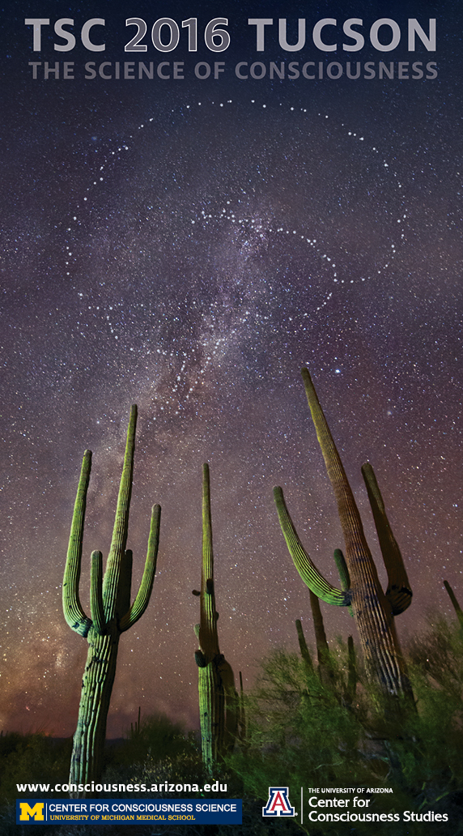

Conference Website
www.consciousness.arizona.edu

